LAB # 12
Working with in MS-Publisher

Introduction
Microsoft Publisher can help you create great-looking publications in less amount of time than you'd spend using a word-processing program. Publisher makes it especially easy by giving you hundreds of professional designs to start from.
Publisher includes designs for newsletters, brochures, Web sites, business cards, postcards, greeting cards, media labels, and more. And once you pick up the basic skills you need to start and customize a publication, you'll be able to apply those same skills to the entire range of personal and business publication types now at your fingertips.

Microsoft Publisher
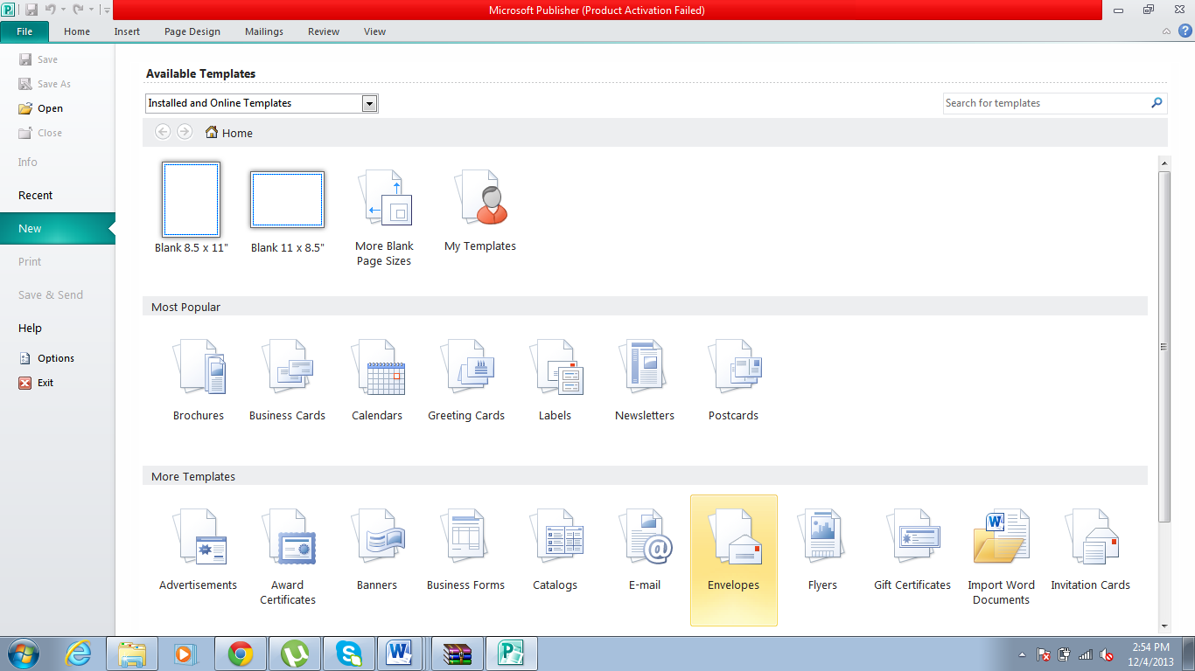
Creating a visiting card for a company
Step 1: Open Microsoft Publisher
Step 2: After selecting the business card option by double click on it. This window will appear:
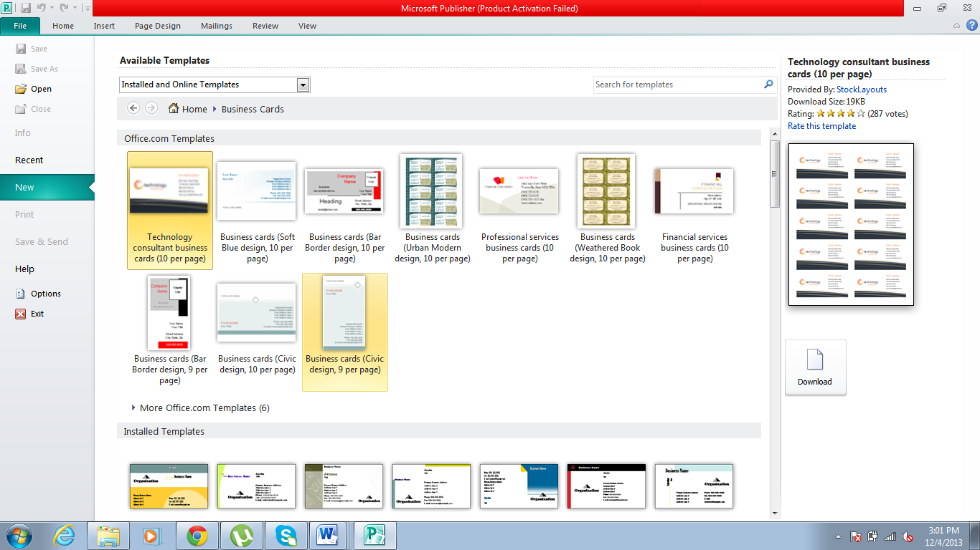
Step 3: After selecting any of the visiting card of your choice by double clicking following window will appear:
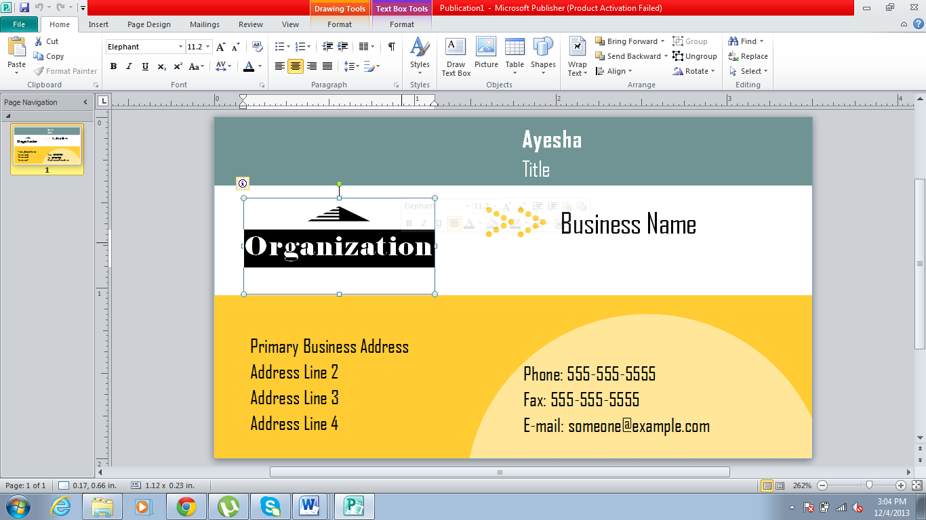
Step 4: After this, you can easily change the material or text according to your requirement.

Creating Website
Step1: For designing website. Following window of a template will appear:
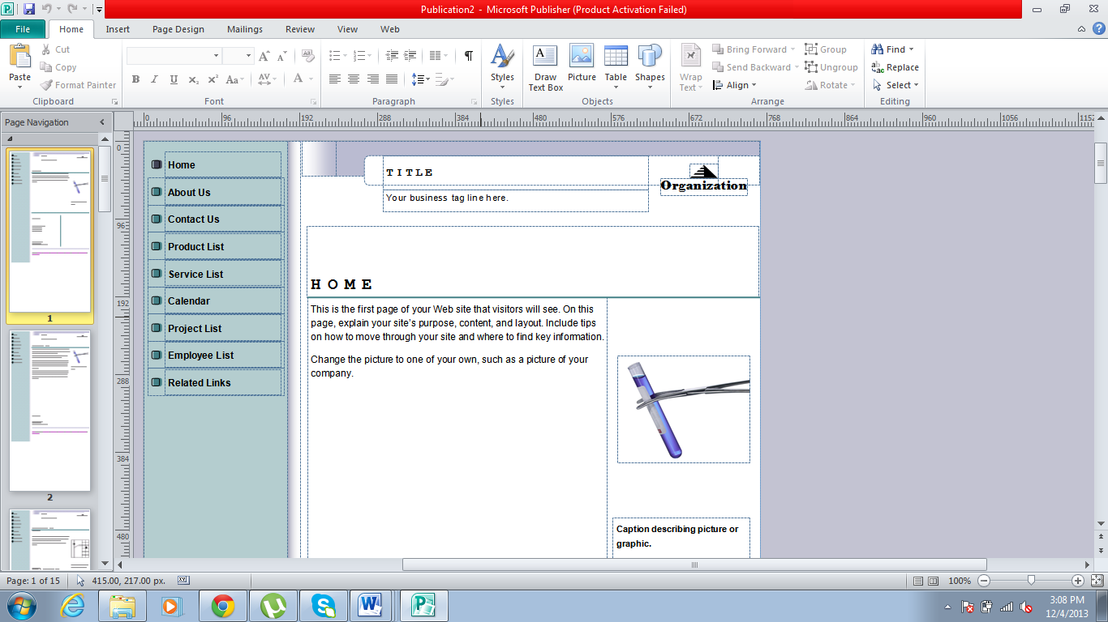
Step 2: You can easily change the text or material according to your requirement.
Step 3: For saving this page, you have to click on save as option in FILE, after that select the following:
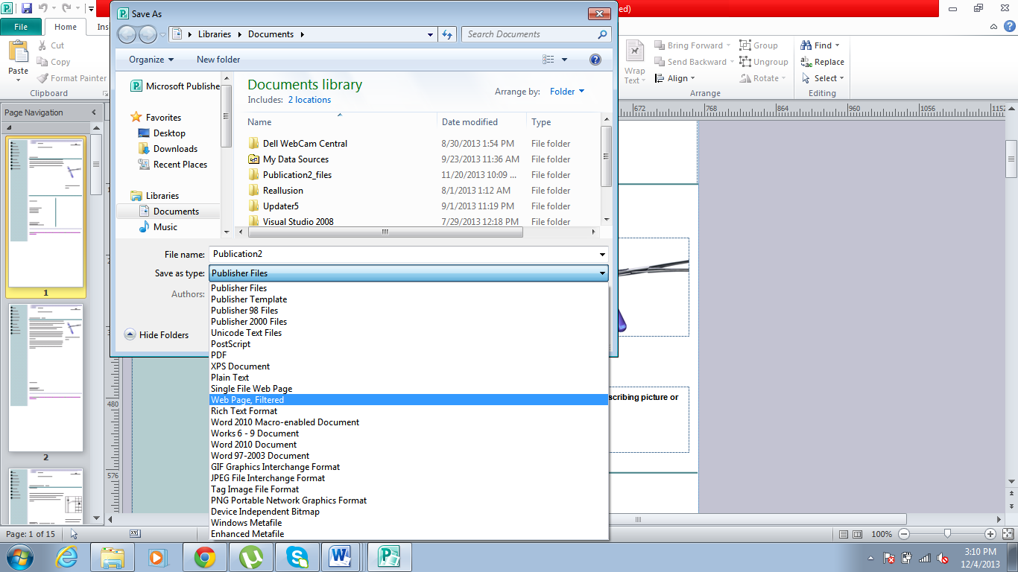
Step 4: For viewing your web page, simply go in that folder in which you have saved your publication.
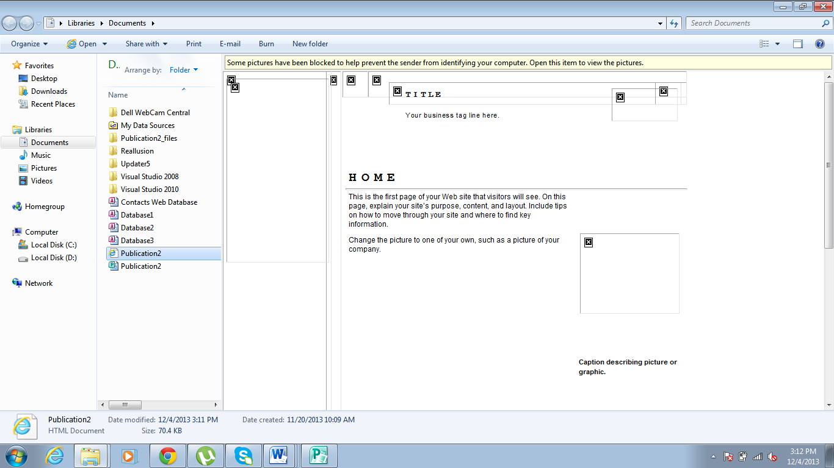
Step 5: By Clicking on the html file with internet explorer icon you can view your publication in explorer:
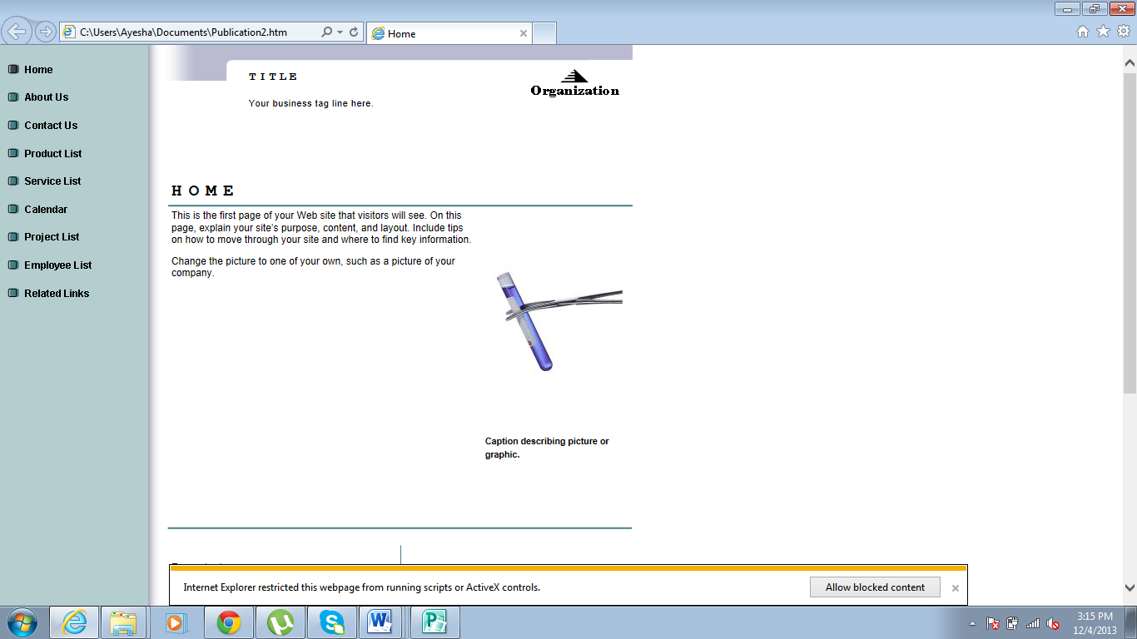

Lab Tasks
Task # 01: Create a visiting card using MS publisher.
Task # 02: Create your own CV using MS publisher.
Task # 03: Create a Broucher using MS publisher.

